Setting up 2-Step Verification on your Google Account
Note: If you have not set up 2-Step on your District (@d93mail.com) account, you will need to reach out to the Technology Department to move your account so you will be able to sign in and follow these instructions.
Note: 2-Step is only mandatory for staff accounts. The district discourages students from setting up 2-step on their district accounts since most teachers do not allow cell phones in the classroom.
Summary instructions of what you need to do:
- Go to your Google Account. (Select link to have you sing in and take you right there.)
- On the left navigation panel, click Security.
- On the Signing in to Google panel, click 2-Step Verification.
- Click Get started.
- Follow the steps on the screen.

Broken down instructions with pictures for the early steps are below if you need.

Go to www.google.com and click the waffle then account. Sign into your d93mail.com account. (If you are signed into a personal account, click the circle at the top right and choose sign out.)
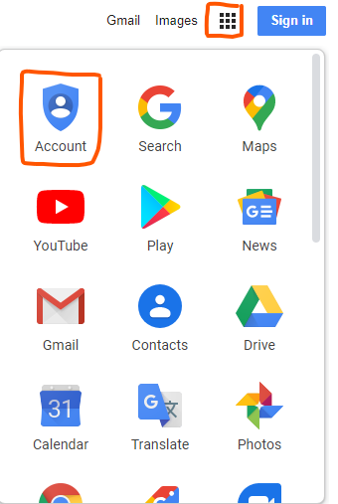
Once you are signed in and have gotten to your account page, then select the security tab on the left side of the page. It will then take you to the security page where you will see a section called Signing in to Google. Select 2-Step Verification to begin the set up.
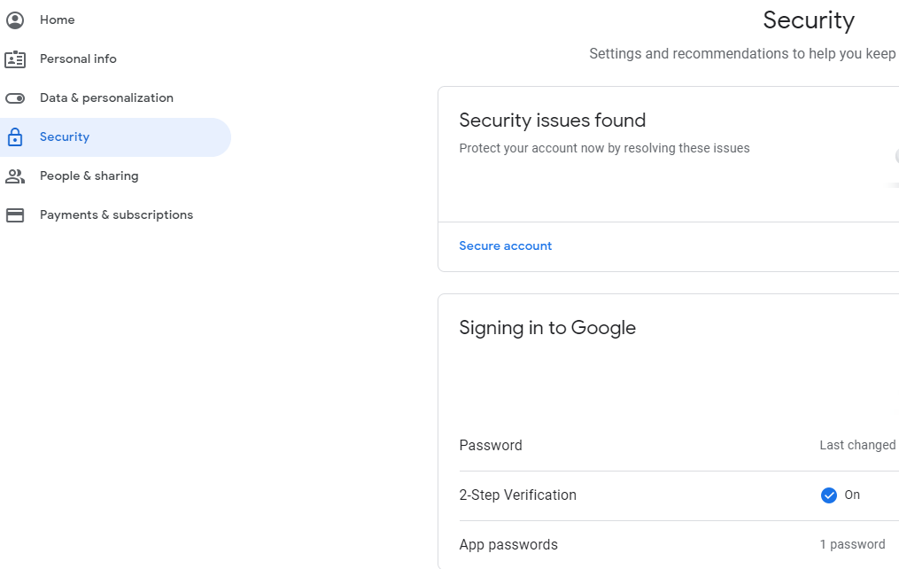
It will probably have you enter your account password again for security purposes before you can continue.
The most common set up’s for 2-step are either having a text sent to your cell phone or a phone call placed to your cell phone. (Do not set up 2-step with a home phone or the schools main line because you won’t be able to get into your account at the schools.)
Setup will verify your phone number by sending a text or a call based on the methood you selected. You will receive a code and enter it and then click verify and if you entered it right, you should be set to go.
When you have it set up, if you go back to the security page you will see like in the image a blue checkmark saying that it is on.

If you need to change the cell phone number you can go into these same settings and click on 2-Step Verification & go to Voice or Text Message and you can eiter click on the pencil to change the phone number, or you can select add phone to add the new cell phone number to the account.
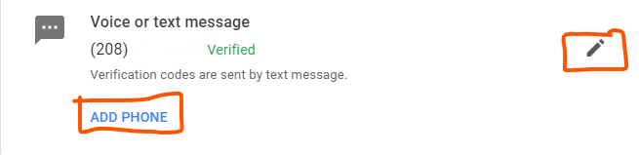

More info & instructions about Google 2-Step Verification such as setting up Google Prompt or setting up code generation with an authenticator app can be found here:
https://support.google.com/accounts/answer/185839?visit_id=1-636241656687776587-1918221694&rd=1
You may follow these instructions for setting up 2-step on a personal Google Account to better secure it if you would like.

Created by: Nathan Egan
Ext. 9328
4-15-20

